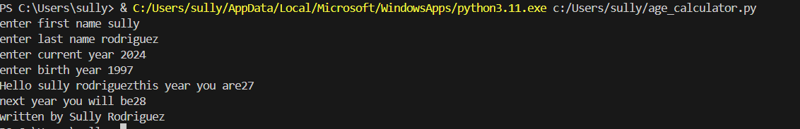

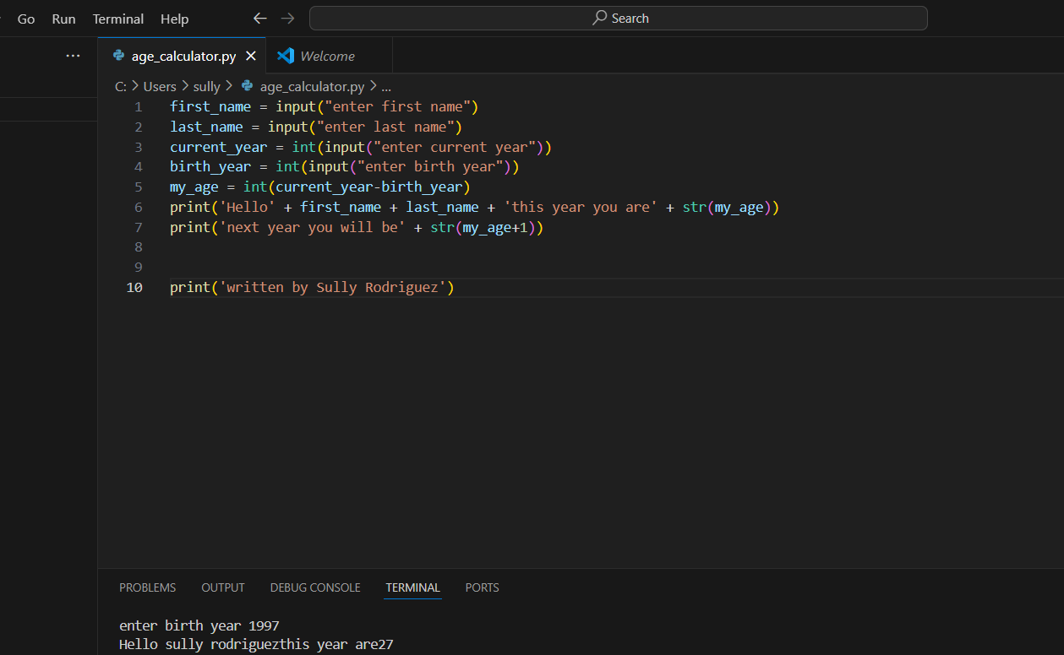

first_name = input("enter first name")

last_name = input("enter last name")

current_year = int(input("enter current year"))

birth_year = int(input("enter birth year"))

my_age = int(current_year-birth_year)

print('Hello' + first_name + last_name + 'this year you are' + str(my_age))

print('next year you will be' + str(my_age+1))

print('written by Sully Rodriguez')